FloodSafe Minute

Flood Protection Products for Rainwater May Prevent Flooding

In addition to a plan for evacuation for hurricanes, homeowners in areas prone to flooding from rain may benefit from purchasing flood protection products to stop flood waters from entering the house or limiting the reach within the house. Dam Easy, Quick Dam, and New Pig are some of the companies that make products that help keep water from coming through doorways or directing water away from the structure. These products are floodwater barriers that fill with air or flood water, dry for reuse, and are available for doorways or to encircle the whole home. Some homes have low areas from enclosed patios and garages or directional flooding from street traffic.

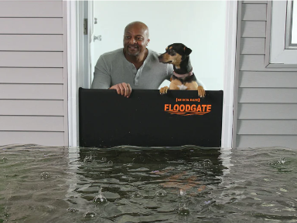 | Flood Gate (patented)  - Quickly blocks entryways in minutes from flood water  - Flood protection up to 26 inches high  - Entryway remains accessible while in use
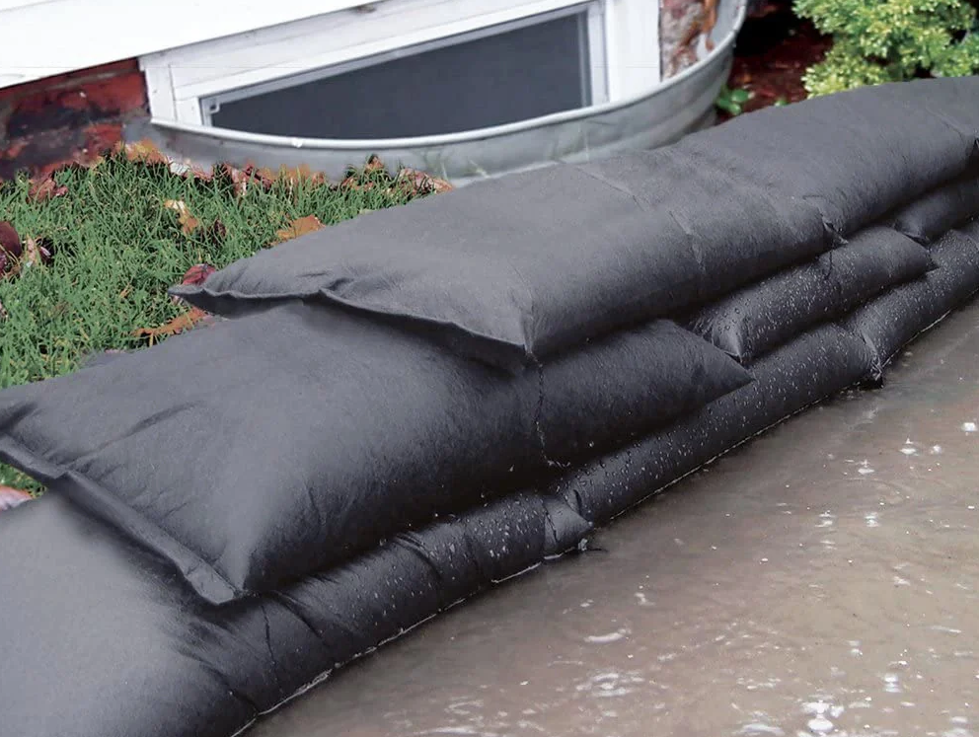 | Flood Bags  - Activates and swells when wet  - No need for sand or labor to fill sandbags  - Stack to create a stable wall
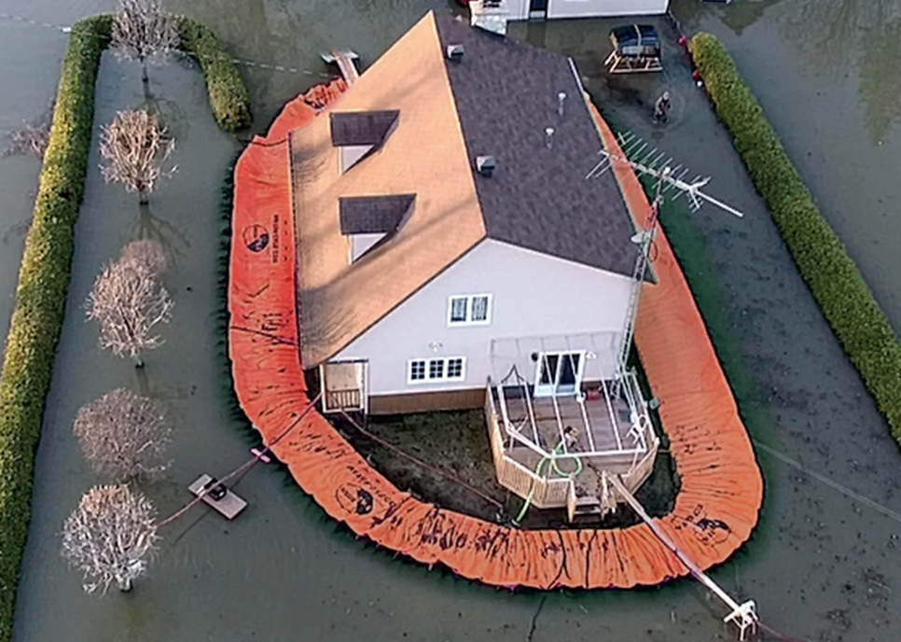 | Water Force  - Portable water dam deploys with minimal time and labor  - Rises with flow of oncoming water and is reusable  - Protection heights from 6 inches to 5 feet

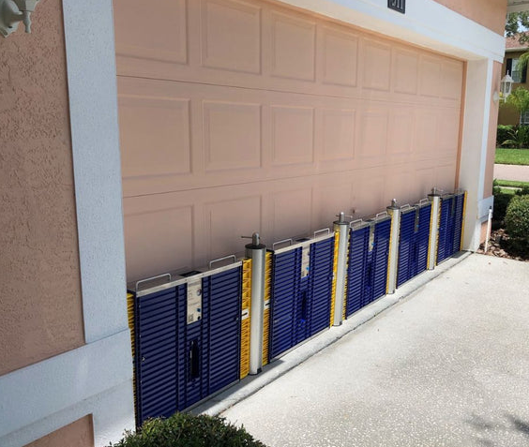
One or more of these products may protect your home. Most of these products can be reused. It may take months for the bags to dehydrate, and they will be heavy until the water evaporates. Some products are not intended for use in salt water, so research if your flood risk is from surge.

When using these products, consider that flood water can come through weep holes as well as the doorways. Costs vary by product and area size to be protected. When shopping, compare the cost of the products to the potential costs of a flood event.

Tiger Dams and Aqua Dams are other products on the market. These options are filled with water prior to the event and then drained for storage and reuse. They can be used in a saltwater environment.

The Parish does not recommend or endorse any particular product or company. This information is provided in response to residents requesting guidance to reduce flooding from rain events.

